Smart Aquaponics Systems

An Aquaponics Solutions utilizing IoT and Azure Cloud Technologies

# The team

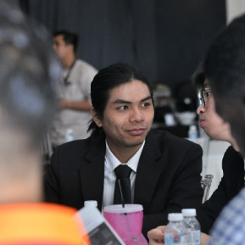

**Muhammad Suzaril Shah bin Zakaria, suzarilshah@gmail.com**

Universiti Kuala Lumpur, Bachelor of Computer Engineering Technology, I am a graduate Network Engineer and technology nerd. Albeit my technical background, I am also a website designer doing freelance in Website Designing, UI and UX. In addition, I spend my free time appreciating classical music (Especially Beethoven's 5th Symphony Allegro Presto) and Arts! Moreover, I like working in teams since learning and working will be easier and more efficient as the saying goes; "Two heads are better than one". I am a passionate learner and are willing to refresh my skills at any time to meet my employee's demand!



**Khairi Azrul Bin Mohammad Asree**, [khairi.asree@s.unikl.edu.my](mailto:khairi.asree@s.unikl.edu.my) , [azrulasree@gmail.com](mailto:azrulasree@gmail.com)

Khairi Asree is taking BE in Networking System at University Kuala Lumpur – Malaysian Institute of Information Technology. He possesses strong understanding in CCNA and has strong passion in Artificial Intelligence. He did a project on implementing OpenCV and Dlib for face recognition in home security system. He also doing IoT and AI project on mangrove sustainability hosted by MEITA in September 2021. He is representative and speaker for Networking Club in many events back in university.



**Muhammad Razin Bin Basar**, [razin.basar@s.unikl.edu.my](mailto:razin.basar@s.unikl.edu.my) , [razinworkplace@gmail.com](mailto:razinworkplace@gmail.com)

Biography:   
Muhammad Razin is taking BE in Networking System at University Kuala Lumpur – Malaysian Institute of Information Technology. He possesses strong understanding in CCNA and has strong passion in Internet of Things (IoT). He did two project involving the IoT framework. Firstly, Floor Switch Detection (Heat, Humidity, CO2) for Ministry of Finance (MOF) Using Arduino and recently he did a project about Automated Aquaponics System to Support Sustainable Development Goals. He also will be doing an IoT and AI project on mangrove sustainability hosted by MEITA in September 2021. Last but not least, he is also one of a Core Team member of a Developer Students Clubs (DSC) in UniKL.

# The Concept

This project presents the applications of Internet of Things (IoT) as instrumentations to automate traditional aquaponics environment. Presently, the economic situation in Malaysia during COVID19, resulting in a significant amount of demand for food production. Correlating to that, research has shown that Aquaponics can help to solve this problem by increasing efficiencies in conventional farming and consequently, increasing food production to the local community in Malaysia. However, extensive and arduous labors have made Aquaponics be costly disadvantageous, especially for small farmers and hobbyists hence making it to be inaccessible to particular group or individuals. This project aims to provide automation to the Aquaponics environment by developing an IoT based prototype to monitor and gather parameter data involving water level, humidity and temperature in the Aquaponics ecology and forecast the data using Azure Machine Learning and AI. Using the aforementioned parameter data, the tendencies and trends in Aquaponics systems can be analyzed. The project features the use of sensors like two water level sensors, liquid temperature sensor, and humidity sensor to collect parameters wirelessly by using an ESP 8266 that will trigger the actuators when certain events are met. The actuator will serve as the balance check for the symbiotic ecology and accommodating parameter it lacks based on the sensor data.

Moreover, the project is divided into three different development phases; setting up normal aquaponics ecology, implementing automation and data forecast in aquaponics systems and lastly analyzing data that comes from the sensor of the prototype. Therefore, this solution is expected to increase efficiencies in the Aquaponics environment without needing human intervention hence reducing the cost of labor in Aquaponics and consequently producing more yield that is organic and healthy. The project will serve a significant impact on the local community, especially during this pandemic outbreak where food production is significantly demanded. In addition, the yield from Aquaponics is unquestionably nutritious, and health enthusiasts will surely benefit from this project making it to be inaccessible to particular group or individuals.

This project aims to provide automation to the Aquaponics environment by developing an IoT based prototype to monitor and gather parameter data involving water level, humidity and temperature in the Aquaponics ecology. Using the aforementioned parameter data, the tendencies and trends in Aquaponics systems can be analyzed. The project features the use of sensors like two water level sensors, liquid temperature sensor, and humidity sensor to collect parameters wirelessly by using an ESP 8266 that will trigger the actuators when certain events are met. The actuator will serve as the balance check for the symbiotic ecology and accommodating parameter it lacks based on the sensor data.

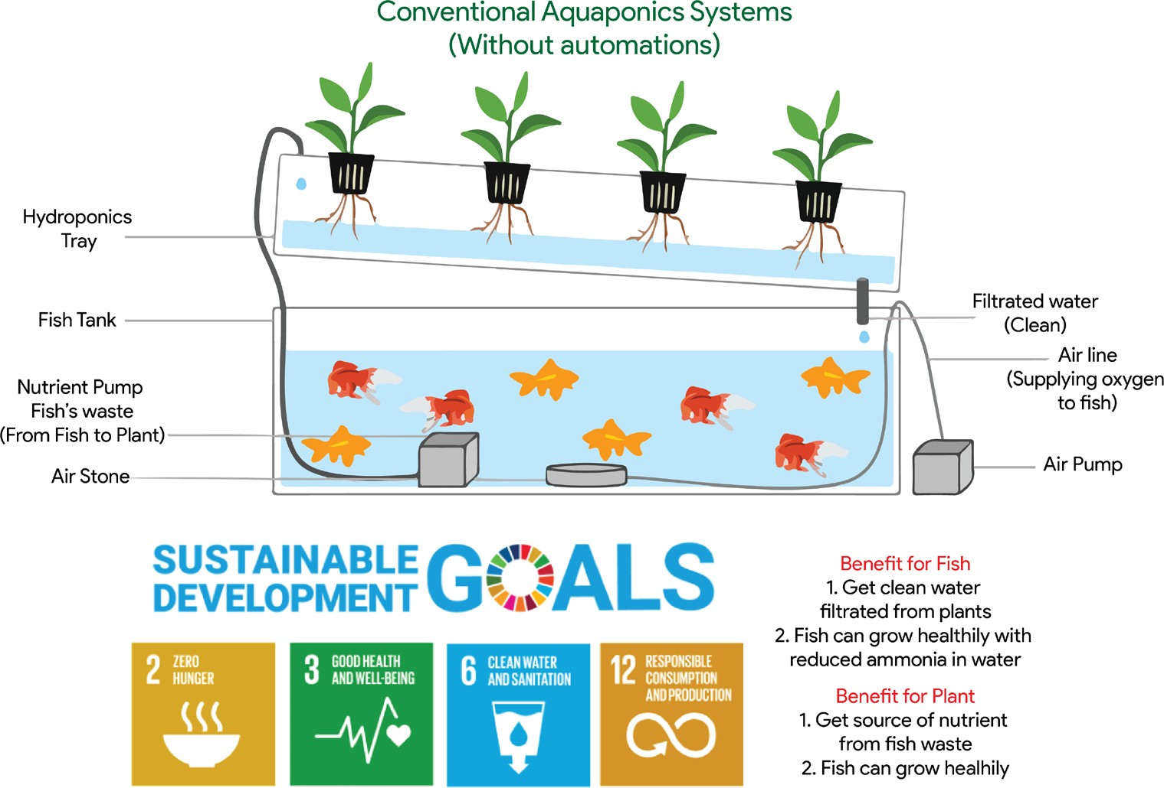

*Figure 1 Aquaponics structure and Benefits [1]*

## Target Audience or Market:

The project not only solves the goals in SDG, but it also holds significant to selected audiences such as individual farmers, farm owners or business owners, as well as hobbyists. In contrast, it helps the economy to grow significantly by producing more crops and fish while increasing the buying power from the local community in Malaysia, especially during this deadly COVID19 virus pandemic outbreak. Besides, the project in itself will have higher commercial value as it can help local farmers and fish breeders to increase food production, which will help the economy significantly. Future investors will sink their fangs to this juicy opportunity to enhance efficiencies in agricultural food production industries which already invaded 7% of Malaysia’s Gross Domestic Product (GDP). Additionally, the project significant can be observed in the following SWOT analysis in which it will extensively dive into the Strength, Weakness, Opportunity and Threat for this project.

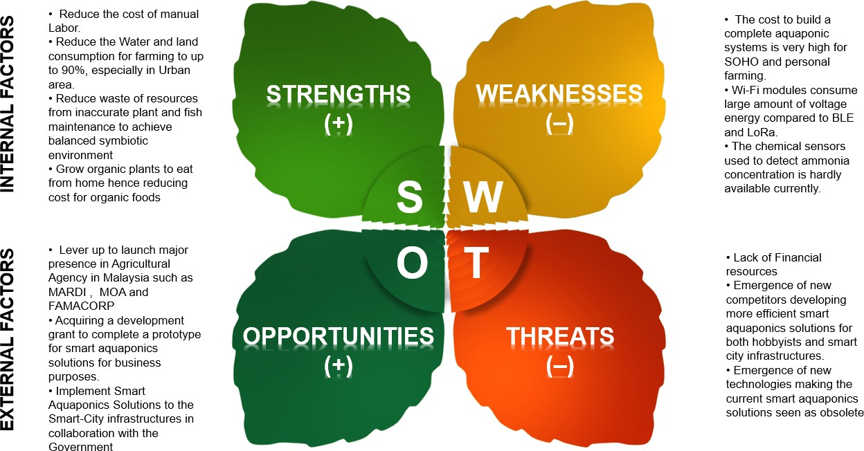

*Figure 1 SWOT analysis for Automated Aquaponics Systems*

## Feedback

* Positive Feedback
  + Can benefit higher crop and fish productivity. decreased use of water, fertilizer, and pesticides, which in turn keeps food prices down. reduced impact on natural ecosystems.
* Negative Feedback
  + Prohibitive cost of maintenance, and low expectation of learnability of the system

# How it works:

**General Concept:**

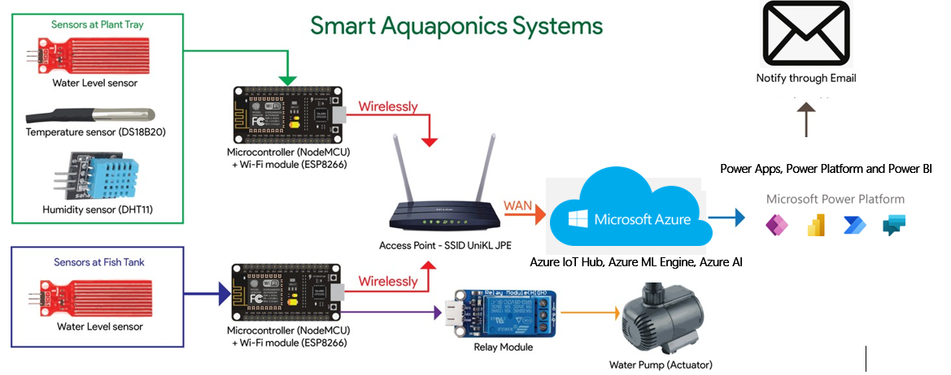

**Physical Diagram:**

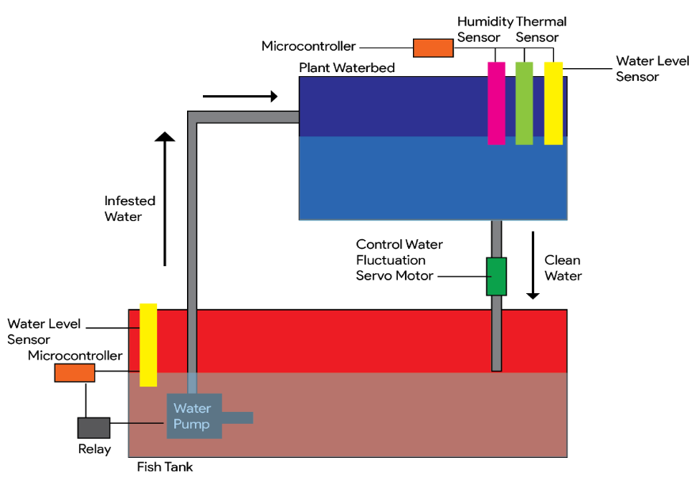

Water Pipe

This phase featured the development stages of Automated Aquaponics Systems. The development stages consist of three main elements; sensors, monitoring and forecasting, and actuators. Before deciding which sensor to use, parameter identification is detrimental, as there is a total of four parameters determined to be included in this project; three for plants and the other one was reserved exclusively for the fish. Also, the parameters that need to be monitored provides water level, temperature, and humidity level. Subsequently, the parameters decided from prior, were measured by implementing hardware sensors such as water level sensor, temperature sensor, humidity level sensor. These sensors will be implemented in Aquaponics ecology to act as receptors for the symbiotic environment.

To monitor these parameters, sensors need to send updates to the Microcontroller and push the data as it forwards it to Azure Cloud via Azure Cloud Storage and Azure IoT Hub. A mobile application developed by using Power Apps with combination with Power BI will display the monitored parameters as well as options to regulate the insufficient parameter that can disrupt the balanced Aquaponics ecology. Not only that, the data forecasted from Azure ML Engine will analyse the state of the farm and give advices to farmer on what to improve. This includes when to change the water, when to feed the fish etc. Associating this into the equation, actuators are needed to restore balance to the Aquaponics environment.

Moreover, the actuators incorporate the use of the water pump in which it was installed in the ecology to regulate the parameters. Likewise, the water pump served to increase water level if the pH level started to turn excessively alkaline, indicating that there are abundant of Ammonia presence in the water that is bad for the fishes. On top of that, by increasing the water level, it made the alkaline yet ammonium infested water to dilute its properties while supplying clean water to the fish to reside in the fish tank.

**Block Diagram:**

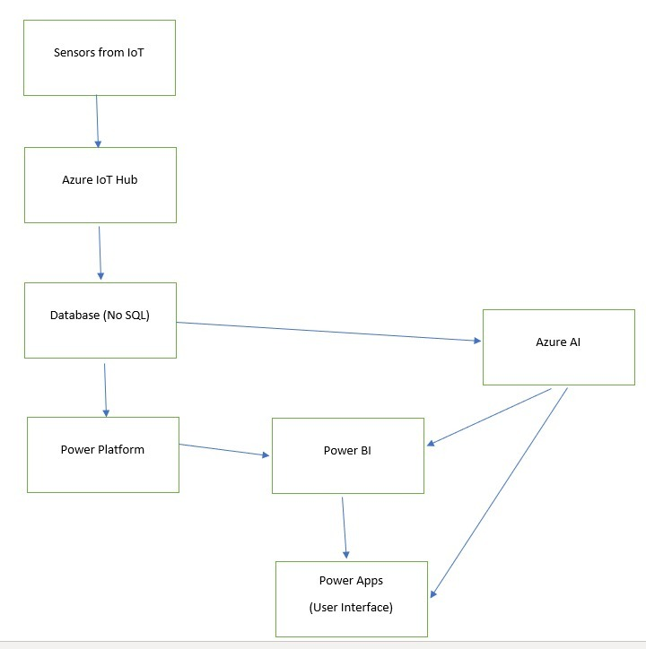

## Core Technologies

**Power Platform**

* Power Apps – to design Interface for the Monitoring Apps
* Power Platform – to connect several data connectors from Data Source (From IoT device)
* Power BI – Display the Data and Intelligently forecast outcome based on the data source

**Azure Cloud**

* Azure IoT Hub – provide monitoring for IoT Nodes
* Azure ML – To determine Fish’s and plants’ health based on the data fed up by IoT sensors
* Azure no-SQL – store the streaming IoT sensors data

# The Business Plan:

The entire business plan can be classified into 4 sections which are market analysis, competitor, implementation plan, and business model. Let proceed with the first section of market analysis.

## Market Analysis (Section A)

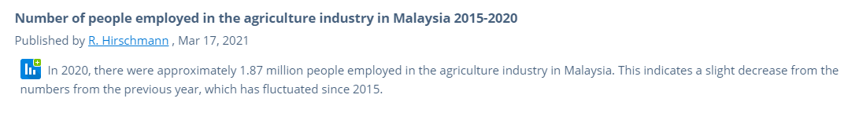*Information gathered from* [*statista.com*](https://www.statista.com/statistics/809602/annual-employment-in-agriculture-industry-malaysia/)

According to a statistic done on 17 of March in 2021, there were approximately 1.87 million people employed in the agriculture industry in Malaysia which means there are at least 1.87 million people are our potential app users excluding those subsistence farmers and gardening lovers. Hence, in order to reach the target market, promotion by analyzing the user's needs is the key to success. Hence, a table was made to summarize the finding on user’s needs and wants:

|  |  |  |  |
| --- | --- | --- | --- |
| **Market Group** | **Expectation** | **Service Derived** | **Most Visited Platform** |
| Commercial Farmer | I need to know which crop make better profit and are in high demand | Advisory System/Crop Market Analyzer | Marketplace/TV program/ Gardening Shop |
| Gardening Lover | I need to know the tips of gardening and the weather of the week | Farming News/Weather Prediction | TV Program/Gardening Shop/Peer |
| Subsistence Farmer | I would like to know the weather of the week and where can I get the crop seed | Location Tracker/Weather Prediction | TV Program/Gardening Shop/Family Member |

*Information gathered from* [*Farm management extension guide*](https://www.fao.org/3/i3231e/i3231e.pdf)

Once the market group being clearly defined, it is time to discuss how our app could reach them. In general, promotion of WAMF app can be done via several common platform as shown in the diagram below.

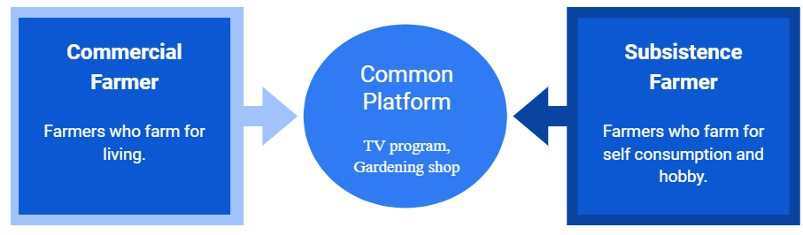

*Common Platform for advertising WAMF*

The first common platform to advertise WAMF is the TV advertisement embedded within the TV program. Currently, there are many gardening and farming TV programs available in ASTRO, Happy TV, or any other TV platform which are suitable for us to deliver the WAMF advertisement. This is because the viewers of these programs are mostly people who are interested or already doing farming and plantation, thus embedding the WAMF advertisement is undeniably a good choice. The second common platform suitable to advertise WAMF is the gardening shop where the farmers will visit often. It was recommended to make an agreement with shopkeepers by asking shopkeepers to be referrers who advertise the app for us to the farmers as they were the person who will probably meet up with farmers and potential app users. Hence in order for the shopkeepers to advertise WAMF, it was crucial to know the competitors which will be discuss in the next section.

## Competitor (Section B)

|  |  |  |  |  |  |  |  |
| --- | --- | --- | --- | --- | --- | --- | --- |
| **Competitors** | | **Free** | **Available in Malaysia** | **Contains Ads** | **Available in Android** | **Available in iOS** | **Advisory Service** |
| Smart Aquaponics Systems  (Proposed) |  |  |  |  |  |  |  |
| Strawberry Advisory System |  |  |  |  |  |  |  |
| Custom Weather Alerts |  |  |  |  |  |  |  |

*Information gathered from* [*croptracker.com*](https://www.croptracker.com/blog/top-ten-weather-apps-for-farmers.html)

Based on the table above, most of the weather app including the WAMF app is free and contains ads but what makes WAMF stand up against other similar apps was its ability to generate farming advice. The weather and crop market information on its own are meaningless, thus the WAMF app offers advisory service to allow farmers to visualize the chances hidden behind all the data and information and this is how WAMF becomes sustainable in the market. Above all, planning without actual action is groundless and pointless hence this business plan contains an implementation plan which will be discussed below.

## Implementation Plan (Section C)

|  |  |  |  |  |  |  |  |  |  |  |
| --- | --- | --- | --- | --- | --- | --- | --- | --- | --- | --- |
| **Gantt chart – Implementation cycle 1** | | | | | | | | | | |
| **Year 2021** | | | | | | | | | | |
| Task | Duration | November | | | | December | | | | |
| 5 | 12 | 19 | 26 | 3 | 10 | 17 | 24 | 31 |
| Ideation | 5 days |  |  |  |  |  |  |  |  |  |
| Code | 28 days |  |  |  |  |  |  |  |  |  |
| Testing | 7 days |  |  |  |  |  |  |  |  |  |
| Debug | 14 days |  |  |  |  |  |  |  |  |  |
| Testing | 7 days |  |  |  |  |  |  |  |  |  |

|  |  |  |  |  |  |
| --- | --- | --- | --- | --- | --- |
| **Gantt chart – Implementation cycle 2** | | | | | |
| **Year 2022** | | | | | |
| Task | Duration | Jan | Feb | Mar | Apr |
| User-acceptance test (survey distributing), Quality assurance test | 2 months |  |  |  |  |
| Closing Response, final correction | 1 months |  |  |  |  |
| Preparing for submit/ Commencement of business | 1 months |  |  |  |  |

## Business Model (Section D)

This section will be discussing how to make a profit with Smart aquaponics Systems. First of all, this app will be a continuous service provider which provides smart aquaponics solution throughout 365 days and generates forecast for how often to change the water in the fish tank and advice for farmers based on current market trends. Based on the case, it is suggested to apply a hybrid version of in-app advertising and subscription monetization strategy to make money.

According to a review by TANOCO ([app monetization guide](https://www.tamoco.com/blog/ultimate-app-monetization-guide/)), advertising is still the most popular app monetization strategy. The same goes to this WAMF app where it can be monetized whenever a farmer views the banner ads or clicks to watch ads throughout the usage of the app. Besides, subscription models are also suggested as specific farming tips and materials (industry trend and agronomist advisor service) are only available for those who are subscribing and this makes more money than a one-shot purchase model.

To conclude, it is suggested to apply both in-app advertising and subscription monetization strategies as both of them are not in conflict with one another and there is no wrong with making more money as long the service is good and sustainable.



# Additional Information:

[1] Badiola, M., Mendiola, D., & Bostock, J. (2012). Recirculating Aquaculture Systems (RAS) analysis: Main issues on management and future challenges. *Aquacultural Engineering*, *51*, 26–35. <https://doi.org/10.1016/j.aquaeng.2012.07.004>

[2] Eding, E., Kamstra, A., Verreth, J., Huisman, E., & Klapwijk, A. (2006). Design and operation of nitrifying trickling filters in recirculating aquaculture: A review. *Aquacultural Engineering*, *34*(3), 234–260. <https://doi.org/10.1016/j.aquaeng.2005.09.007>

[3] Tyson, R. V., Treadwell, D. D., & Simonne, E. H. (2018, December 12). *Opportunities and Challenges to Sustainability in Aquaponic Systems in: HortTechnology Volume 21 Issue 1 (2011)*. HortTechnology. <https://doi.org/10.21273/HORTTECH.21.1.6>

[4] Palm, H. W., Knaus, U., Appelbaum, S., Goddek, S., Strauch, S. M., Vermeulen, T., … Kotzen, B. (2018). Towards commercial aquaponics: a review of systems, designs, scales and nomenclature. *Aquaculture International*, *26*(3), 813–842. <https://doi.org/10.1007/s10499-018-0249-z>

[5] Murali, R., Bhalla, A., Singh, D., & Singh, S. (2017). Acute pesticide poisoning: 15 years’ experience of a large North-West Indian hospital. *Clinical Toxicology*, *47*(1), 35–38. <https://doi.org/10.1080/15563650701885807>

[6] Kori, R. K., Singh, M. K., Jain, A. K., & Yadav, R. S. (2018). Neurochemical and Behavioral Dysfunctions in Pesticide Exposed Farm Workers: A Clinical Outcome. *Indian Journal of Clinical Biochemistry*, *33*(4), 372–381. <https://doi.org/10.1007/s12291-018-0791-5>

[7] West, J. (2017, November 21). *How Much Azomite Per Square Foot?* SF Gate. <http://homeguides.sfgate.com/much-azomite-per-square-foot-87735.html>.

[8] Shorette, K. (2012). Outcomes of Global Environmentalism: Longitudinal and Cross-National Trends in Chemical Fertiliser and Pesticide Use. *Social Forces*, *91*(1), 299–325. <https://doi.org/10.1093/sf/sos053>

[9] Green Garage. (2019, December 16). *7 Pros and Cons of Conventional Farming*. Green Garage. <https://greengarageblog.org/7-pros-and-cons-of-conventional-farming>.